1. SELECT customer.id_customer, customer.nama, customer.no_telepon, orders.nomor_order, orders.tanggal_order, orders_details.jumlah_order, barang.nama_barang, barang.harga_barang, supplier.nama, supplier.alamat, supplier.no_telepon, supplier.email

FROM customer

JOIN orders ON orders.id_customer = customer.id_customer

JOIN orders_details ON orders_details.nomor_order = orders.nomor_order

JOIN barang ON barang.id_barang = orders_details.id_barang

JOIN supplier ON supplier.id_supplier = barang.id_supplier;

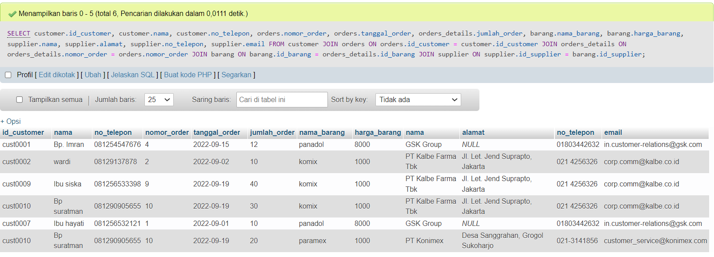

1. SELECT customer.id_customer, customer.nama, customer.no_telepon, orders.tanggal_order, orders_details.jumlah_order, barang.nama_barang,supplier.nama AS nama_supplier, supplier.alamat AS alamat_supplier

FROM customer

JOIN orders ON orders.id_customer = customer.id_customer

JOIN orders_details ON orders_details.nomor_order = orders.nomor_order

JOIN barang ON barang.id_barang = orders_details.id_barang

JOIN supplier ON supplier.id_supplier = barang.id_supplier;

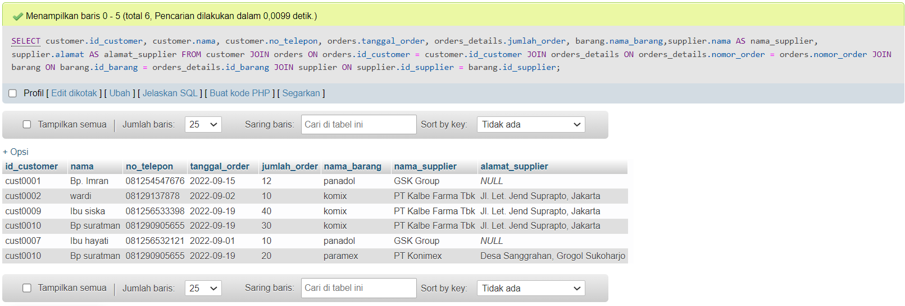

1. SELECT customer.nama AS nama_customer, orders.tanggal_order, orders_details.jumlah_order, barang.nama_barang, barang.harga_barang, supplier.nama AS nama_supplier

FROM customer

JOIN orders ON orders.id_customer = customer.id_customer

JOIN orders_details ON orders_details.nomor_order = orders.nomor_order

JOIN barang ON barang.id_barang = orders_details.id_barang

JOIN supplier ON supplier.id_supplier = barang.id_supplier;

